Grade 3 Weekly Homework Sheet: Week of January 14-18, 2019
For homework, projects, news and upcoming events log on to http://ps136.weebly.com/

Vocabulary: panhandle, barter, negotiate, vendor, shadows, burlap, ptarmigan, pontoon, hunker, moccasins.

**2-sided Homework Sheet**
Monday – January 14, 2019

- Reading: Read for 35 minutes and record on your Reading Log. Jot down character traits or theories that describe the main character in your book.
- Phonics: What is a homograph? Jot down any homographs you come across as you read.
- Writing: Write a paragraph describing Opal from the book, “Because of Winn Dixie.” (Use some character traits within your paragraph)
- Math: Chapter5. Lesson 5.3 Pages 279 and 280 do even numbers only. Study times tables 6-8. Visit engageny.com!!
- Science: Create a model floating train using materials around your home. Please try and be creative (3-D model) Due Wednesday, January 23.

Parent Signature: ____________________

Tuesday – January 15, 2019

- Reading: Read for 35 minutes and record on your Reading Log. As you read, jot down any patterns you notice about your character. (What they say or do.)
- Phonics: What is the difference between a homophone and a homograph? Give 2 examples of each.
- Writing: Write a paragraph describing Opal and the preachers’ relationship.
- Math: Chapter 5. Lesson 5.4 Pages 285 and 286 do odd numbers only! Study and write out times table 8 and 9.
- Science: Work on the floating train project, which is due on January 23.

Parent Signature: _______________________

****Please check homework every night! Please empty out homework folders daily****
**Reminder…Students must come to school prepared with four sharpened pencils each day**

Wednesday – January 16, 2019
Reading: Read for 35 minutes and record on your Reading Log. Was it wrong for Mamma to keep Bokko at home? Explain.
As you are reading, jot down character traits that describe the characters in your book. For example: Suzy is bored.
- Phonics: Create sentences with the following homographs: bass, bow, fine, clear.
- Writing: Do you think it was right for the first teacher to leave Fred’s school? Use details from the text to support your answer.
- Math: Chapter 5. Lesson 5.5 Pages 291 and 292 do even numbers only! Study and write out times tables 9-10. Visit engageny.com!
- Science: Continue working on your floating train project. Be creative.

Parent Signature: _______________________

Thursday – January 17, 2019
- Reading: Read for 35 minutes and record on your Reading Log. How is the character similar to you? Do you share any traits?
- Phonics: Complete worksheet on homographs.
- Writing: Write two paragraphs describing how Opal thinks, feels, or reacts to the events in the story?
- Math: Study for your Chapter 5 test!! Study and review pages 293-298.
- Social Studies: Write a paragraph describing Nike Davies-Okundaye. What is she famous for? Why is she an important person in Nigeria?

Parent Signature:_________________________

Friday – January 18, 2019
- Reading: Read for 35 minutes and record on your Reading Log.
Can you think of another book that is similar to the one you are reading? How is the character in this text similar to a character in another text based on circumstances, traits, or actions?
- Phonics: Complete the worksheet on homophones.
- Writing: How are Miss Agnes’s actions different from what Fred expects a teacher to do? Use evidence from the text to support your opinion.
- Math: Study times tables 2-9. Solve on loose leaf paper: Shakira went to Barnes and Noble book store. She purchased 6 books at $8 each. Then, she bought a bookmark for 3 dollars. How much did she spend in all? If she paid with three $20 dollar bills, how much money did she get back?
- Social Studies: Explain the Adire Cloth. Why is this cloth important in the Nigerian culture?

Parent Signature: _______________________

/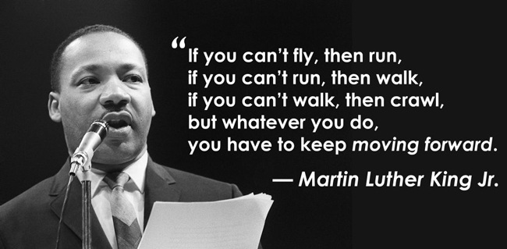

\

Monday is the national celebration of Dr. Martin Luther King, Jr.’s birthday. School is closed on Monday, January 21, 2019. Students will return on Tuesday, January 22, 2019.

